MHF4U EXAM 1

|  |  |  |  |  |
| --- | --- | --- | --- | --- |
| Instructor: | K.Liu |  | Name: |  |
| Results: |  |  | Class: |  |
|  |  |  | Period: |  |
|  |  |  | Date: |  |

Type the test instructions here. For example, instruct the student to carefully read each question and then circle the letter of the correct answer.

1. State the degree, dominant term, leading coefficient, Even/Odd, End Behaviors, and number of turning points of the polynomial for the function
2. For the functions in the previous questions, Sketch a possible graph of each functions. Clearly indicate the x-intercepts and y-intercepts.
3. Find the average rate of change of the function over the given interval.

d.

1. The displacement, s, in metres, of a particle moving back and forth in a straight line can be modeled by the function . is measured in seconds.

Find the average rate of change of the distance with respect to time from 1s to 4s.

1. The population, P, of a small town is modelled by the function  
    , where represents the beginning of this year.
   1. Write an expression for the average rate of change of population from to
   2. Use the expression in part a) to determine the average rate of change of the population when

6. Write a possible function for the following graphs using factor form:

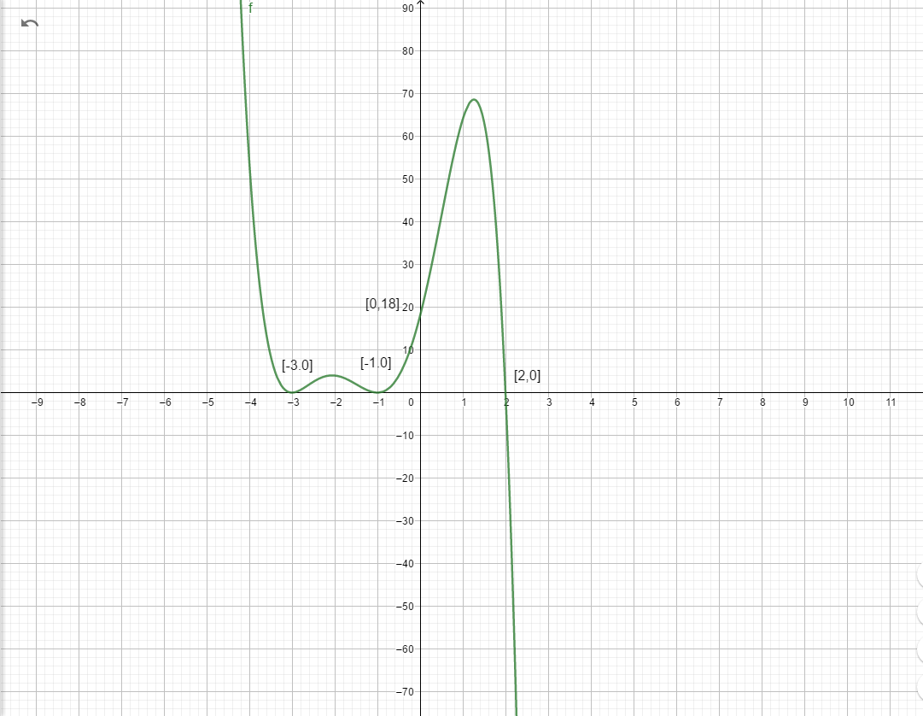

1. 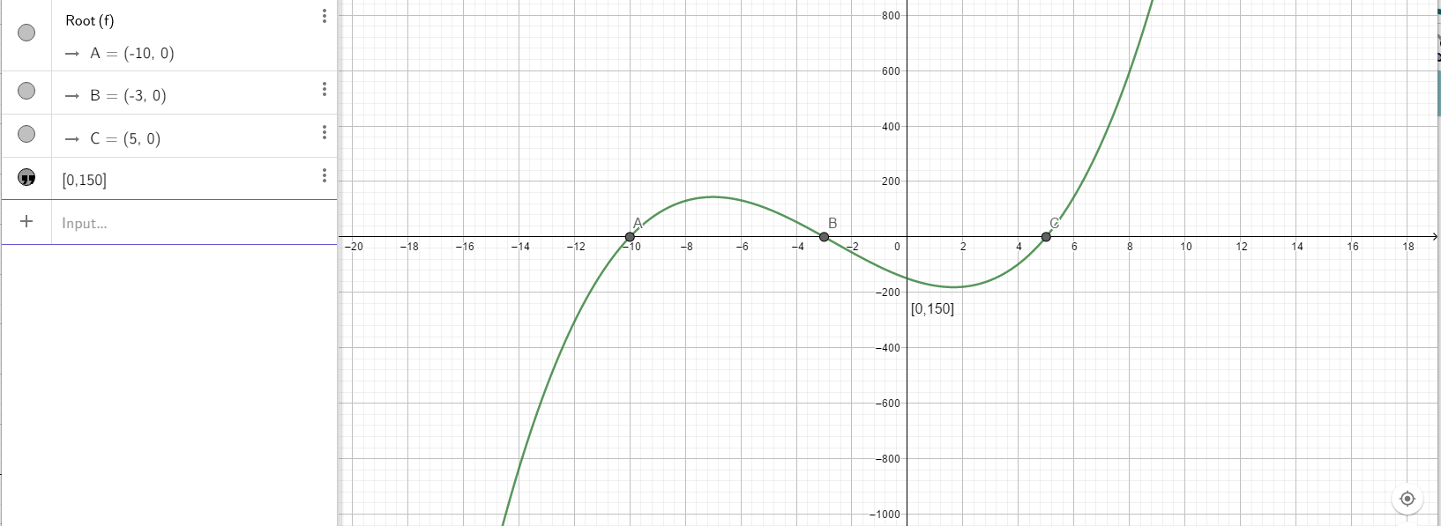
2. 